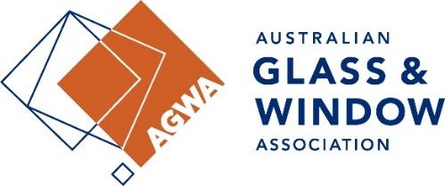
National Technical Alert

NCC 2025 Preview Launched
Action Required: | Awareness of the publication of this preview edition
Issue affects: | Aluminium Window Manufacturers and Systems Companies, Glass Manufacturers, Glass Processors, Glaziers, Hardware Manufacturers and suppliers
Target Group | Window Technical Committee, Glass Technical Committee
Summary: | The preview of the NCC 2025 was released on the 1st Feb 2026. This is still a draft document; AGWA will be undertaking a review of these documents and will look to circulate key information via members forums and Technical Fact Sheets.

Summary:

On Sunday 1st Feb 2026 the preview editions of the National Construction Code 2025 were released. The files can be accessed here: https://ncc.abcb.gov.au/

These documents are a preview draft of NCC 2025, it is not a document for Public Comment but a preview of the final version which may be adopted by Australian states and territories from 1 May 2026. No formal announcements by any state have been made on this to date or if there are to be any state and territory variations or additions

Additionally, some sections of the preview draft are omitted because the publication of NCC 2025 is yet to be completed. There is a supplementary document containing omitted text and is to be read in conjunction with other preview draft documents.

AGWA will be undertaking a review of these documents and will look to circulate key information via members forums and Technical Fact Sheets however the key changes relate to Volume 1 (i.e. class 2- 9 buildings) around:
• Updated Referenced Documents,
• Waterproofing of balconies in apartment buildings,
• Commercial energy efficiency,
• Alternative referenced documents

There are no changes to Volume 2 which covers Housing outside of aligning with updated standards and other referenced documents.

James Whitehouse

james.whitehouse@agwa.com.au

